2023 GLIFWC Biological Services Division
“Recharge 6—Waawaashkeshi Workshop”
Bad River Food Sovereignty, Odanah WI
December 4-6, 2023

By

Kristen Thannum
Administrative Assistant to the Biological Services Director

&

Dr. Jonathan Gilbert
Biological Services Director

Administrative Report 23-09

GREAT LAKES INDIAN FISH
& WILDLIFE COMMISSION
Biological Services Division
P.O. Box 9
Odanah, WI 54861
(715) 682-6619
www.glifwc.org

2023 Recharge Biological Services Division Attendance
Aaron Shultz, Climate Change Inland Fisheries Biologist
Adam Ray, Inland Fisheries Biologist
Adam Oja, Wildlife Technician
Alex Bohman, Forest Ecology Program Coordinator
Allison Carl, Wildlife Biologist
Brandon Byrne, Wetland Ecologist
Caren Ackley, Environmental Biologist
Dara Unglaube, Database Manager
Dawn White, Treaty Resource Specialist
Hannah Panci, Climate Change Scientist
Joe Dan Rose, Inland Section Leader
John Coleman, Environmental Section Leader
Jonathan Gilbert, Director, BSD
Jose Estrada, Wildlife Technician
Kathleen Smith, Ganawandang Manoomin
Kia Hmielewski, Data Manager
Kristen Thannum, Administrative Assistant
Mark Luehring, Inland Fisheries Biologist
Miles Falck, Wildlife Section Leader
Steve Garske, Invasive Species Coordinator
Travis Bartnick, Wildlife Biologist
Travis Swanson, Forest Ecologist

Acknowledgements

We would like to extend our gratitude to the following groups and individuals who shared their time, resources, and effort towards the 2023 Winter Recharge.

- Cat Techtmann –University of Wisconsin-Extension assisted with planning, supported GLIFWC staff by working behind the scenes so that skills training activities went smoothly, and led our Wellness Wheel activity Wednesday morning at the Bad River Housing Building.

- Our GLIFWC Wildlife Technicians Jose Estrada, John Wilmer Jr., and Adam Oja, who all were instrumental in preparations for the event including assisting with shopping for supplies, set up and cleanup of venues, and making arrangements with Bad River Food Sovereignty staff.

- Our GLIFWC staff, who donated their time and supplies to lead skills training. Jose taught us how to properly marinade and prepare venison jerky, Travis Swanson shared his family recipe for a delicious potato sausage, Caren Ackley made us all delicious fry bread for lunch on Tuesday, and John Coleman, who shared his canning expertise so that staff could learn to can venison and pumpkin.

- Bad River Food Sovereignty for the use of their wonderful facility.

- Maria Nevala and John D. Lemieux, who shared their time and talents to show us how to knuckle skin, debone, and butcher venison. Furthermore, Maria donated wild rice and walked GLIFWC staff through the process of making wild rice and dried berry brats.

- Sean Bresette, a young tribal member who utilized his treaty rights and hunting skills to provide the deer that we processed.

- Jen Falck representing the non-profit organization Ohe Láku - Among the Cornstalks, who demonstrated the proper way to prepare white corn.

- GLIFWC Planning Team – Cat Techtmann, Adam Oja, Caren Ackley, John Coleman, Dawn White, Esteban Chiriboga, Travis Bartnick, Miles Falck, Kristen Thannum, and Jon Gilbert, who all dedicated time out of their busy schedules to plan the Recharge.

- Our volunteer chefs for Wednesday morning who prepared a delicious breakfast for Biological Services Staff: Kathleen who fried us up some fresh venison breakfast sausage that was made the previous day, Dawn who sauteed some delicious venison with onions, Brandon who cracked and scrambled eggs for 30 people, and Miles who held it down at the toaster station.

Introduction
There’s been a lot of change around GLIFWC in the last few years between the CoVid19 Pandemic, new staff joining GLIFWC, and new leadership in place. For this ReCharge, we wanted to reconnect to the core mission of GLIFWC, which includes infusing traditional Anishinaabe culture and values into our day-to-day work at GLIFWC. As much of the division consists of biologists, we wanted to give staff an opportunity to step away from the academics and office work that usually makes up most of the workweek in order to experience food processing from the perspective of the tribal members we serve. When we work on so many biological issues throughout Indian Country, we can sometimes lose the focus on why we care about these issues, and who they affect the most.
GLIFWC BSD RECHARGE AGENDA
12/4 - Monday | 12/5 - Tuesday | 12/6 - Wednesday
Prep Food Sov. Building and Bio Garages | Breakfast at the Biology Garages | Staff Breakfast at BR Housing Gathering Room
Welcome by Dr. Gilbert and prayer by Manidoo Noodin (Executive Administrator Jason Schlender) | Sausage and Brat Demonstrations by Maria & JD, and Travis Swanson
Knuckle Skinning Demonstration by Maria and JD | Staff Lunch at Food Sov. | Introduction by Dr. Gilbert
Deer processing – deboning and butchering | Canning Demonstration by John Coleman
Canning preparations | White Corn soup Demonstration by Jen Falck | Wellness Medicine Wheel Activity with Cat Techtmann
Corn Prep with Jen Falck | Jerky Demonstration by Jose Estrada
Food Safety Demonstration by James Thannum | Staff Dinner at Food Sovereignty Building

The Planning Team wanted to choose both a skill building activity that incorporates Traditional Ecological Knowledge (TEK), as well as team building and strategic planning discussions to focus on ways we can improve as a division. The Planning Team decided on a Waawaashkeshi Workshop, where staff could learn the process of skinning, butchering, and processing the meat of waawaashkeshi (deer). This would be followed by teambuilding and workplace improvement discussions using the Medicine Wellness Wheel activity on the last day to close out the Recharge. The 2023 Winter Recharge took place at the Bad River Food Sovereignty Building and the Bad River Housing Gathering Room.
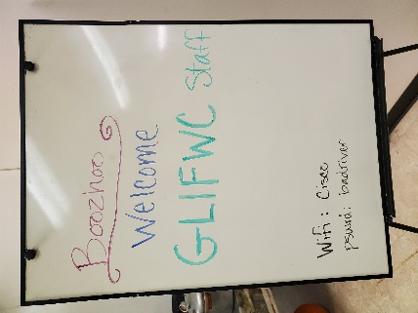
Monday – December 4th, 2023
Bad River Food Sovereignty Building - 8:00 AM to 6:00 PM
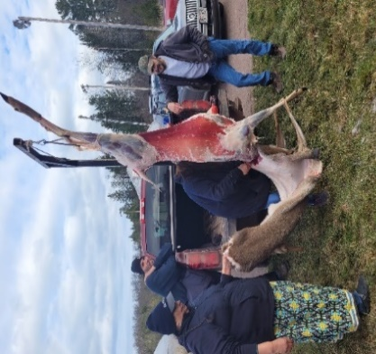
On Monday morning Biological Services staff gathered at the Bad River Food Sovereignty building. After a welcome from Dr. Jonathan Gilbert, Manidoo Noodin (Jason Schlender) started us off in a good way with a morning prayer. He told staff how he started that morning by lighting the aseema Dr. Gilbert had given him and prayed with the tobacco for the recharge that morning.
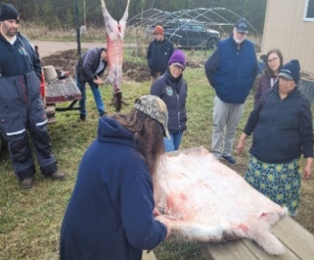
The first demonstration of the day was “knuckle skinning” with Bad River tribal members JD Lemieux and Maria Nevela. They demonstrated how to skin the deer by hand and how this process leaves the hide intact with minimal debris left on the skin. GLIFWC staff took turns trying their hands at knuckle skinning, and successfully removed the hide in one piece with no damage with the assistance of their mentors.
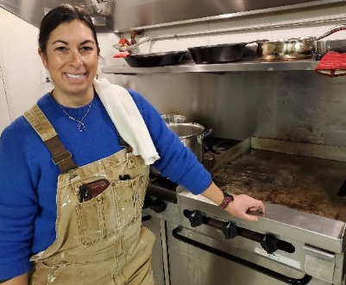
Following the knuckle skinning was a presentation by Planning and Development Director, James Thannum. James has hosted multiple Hazard Analysis Critical Control Point (HACCP) food safety seminars, and educated the staff on proper meat handling, disinfecting, and storage protocol.
Once staff was properly educated on food safety, JD and Maria demonstrated how to quarter, debone, and process the deer that was harvested by Sean Bresette, a Bad River tribal member who was kind enough to donate his time, effort, and harvest for the Recharge. The meat was processed and sorted by cut for one of three uses: cubes for canned venison, strips for jerky, and larger chunks to be ground into sausage meat.
Concurrently, Jen Falck was in the main kitchen area, where she demonstrated the traditional processing of white corn. She taught how the corn needed to be boiled in ash wood, which dissolves the thick outer hulls the
human body cannot digest. This was done in preparation for the meals for Recharge day two and three.
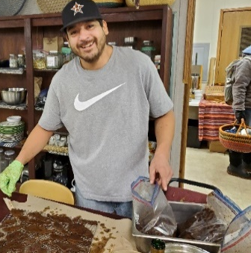
The day came to an end with a staff meal and bonfire at the biological services garages across the street from the Food Soverignty building. The shared meal was potluck style, and the Inland Fisheries crew was kind enough to grill up some brats and hot dogs so the staff could enjoy a well earned warm meal.

Tuesday – December 4, 2023
Bad River Food Sovereignty Building – 9:00 AM to 6:00 PM
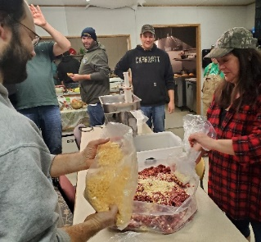
Day two started off chilly, with one of the first snows of the season hitting overnight. Back at the Food Sovereignty building, Wildlife Technician Jose Estrada shared his secret jerky recipe and demonstrated how to marinate the meat prior to smoking to ensure the best flavor.

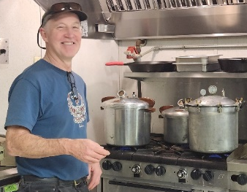
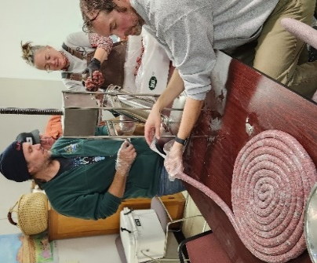
After the jerky was marinading, attention turned back to JD and Maria, who demonstrated the next step to making sausage. Maria mixed the meat that had been cleaned and cut up the previous day with pork and other seasonings, then showed how to properly operate the stuffer. Between the cheesy breakfast sausage and the wild rice and berry brats Maria showed staff how to make, over 40 lbs. of sausage were processed on day two. This was enough that each attendee had the opportunity to take a sample home to share with friends and family. The last sausage that we made was Potato Sausage, a recipe shared by Forest Ecologist Travis Swanson. Travis’s family recipe called for onions and potatoes, as well as a custom spice blend.
Meanwhile in the kitchen, Environmental Section Leader John Coleman showed the group proper canning technique for venison and pumpkin, as well as roasted pumpkin and pumpkin seeds for dinner.
In the evening GLIFWC staff, demonstrators, and tribal elders gathered in the Food Sovereignty Building for a shared meal. The group enjoyed traditional foods like venison with mushroom and onions, Maria’s wild rice casserole, and white corn salad and soup from the previous day’s white corn. Dr. Gilbert closed out the day by thanking everyone for their hard work.

Wednesday – December 4th, 2023
Bad River Housing Building – Gathering Room - 8:00 AM to 1:00 PM
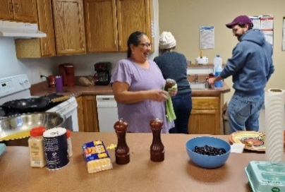
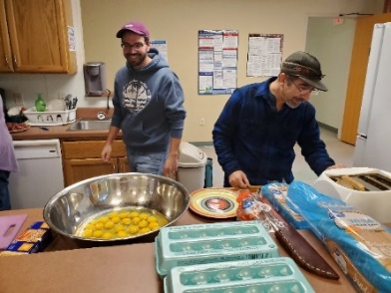
On Wednesday morning, staff gathered at the BR Housing Gathering Room for day three of the Recharge. Brandon Byrne, Kathleen Smith, Dawn White, and Miles Falck arrived early to prepare a delicious breakfast for Biological Services Staff: Kathleen fried us up some fresh venison breakfast sausage that was made the previous day, Dawn sauteed some delicious venison with onions, Brandon who cracked and scrambled eggs for thirty people, and Miles who held it down at the toaster station.
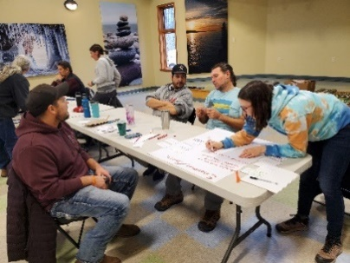
Dr. Jonathan Gilbert started the day off with an introduction and welcome to staff. He explained that the day’s goal was to assess how staff currently felt about working in the Biological Services section by rating different aspects of the Commission. This assessment builds on the wellness training professional development the BSD Team participated in earlier in 2023. To gauge and record responses, Staff rated their current level of wellness in working in the BSD Division using the 4 Directions Wellness Wheel Activity developed by Cat Techtmann.

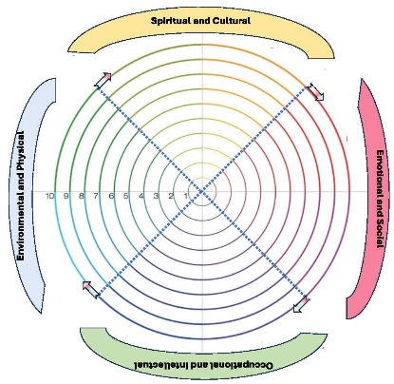
The 4 Directions Wellness Wheel consists of four categories: Environmental/Physical, Spiritual/Cultural, Occupational/Intellectual, and Emotional/Social. The goal of this activity was to identify areas with needed improvement within the Biological Services division. Staff rated each category on a scale of one to ten, then got into groups where they tallied the scores and marked them on a posterboard. The results of the Wellness Assessment can be found on the graph below. For an in-depth analysis, please see Appendix I.

The Wellness Wheel Assessment showed a range of responses, with most staff rating was Spiritual/Cultural with an average rating of 7.6 out of 10. The suggestions for this category were more beginner level language classes for those interested in learning Ojibwemowin, as well as continued support for talking time away from current job duties to attend GLIFWC cultural events, feasts, memorial runs, and traditional medicine harvesting.
The second highest rated category was Occupational/Intellectual the highest with an average rating of 7.5. While rating each category, employees listed suggestions on ways we can improve in each category. The main feedback for the Occupational/Intellectual category was requested for additional training opportunities, as well as more interdepartmental communication on a regular basis.
The second lowest rated category was Emotional/Social with a 7.4. The biggest feedback in this category was a request for better communication, and opportunities to spend more time together, whether it be collaborating on projects, increased intersectional meetings, or teambuilding activities like group walks.
Finally, the lowest rated category was Environmental/Physical with an average rating of 7.4. The main feedback was regarding the current HVAC system and heating/cooling issues in the current GLIFWC building that can make it hard for staff to focus.
The main takaway from the assessment was that GLIFWC Biological Services staff want to work towards a more collaborative, communicative division. The suggestions for more cultural events would allow the opportunity for more inter-sectional conversations to take place, which would be the foundation needed to work in a more cooperative manner moving forward.

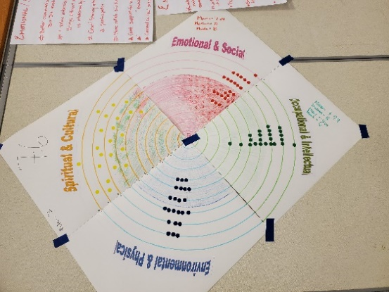
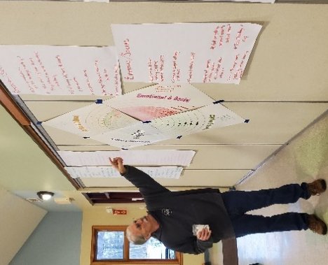

The BSD’s completed wellness wheel visually showing the composite of individual wellness values in each of the wellness categories. Dr. Gilbert reviews results of the Wellness Wheel activity and BSD team members suggestions for improving overall wellness in the future.

Miigwech to BSD staff and ReCharge Planning Team members who for their willingness to plan and participate in this event and making it a success!
Appendix I –Analysis Of BSD Well-Being Assessment And Values by Dr. Jonathan Gilbert

Introduction
In this activity, we are seeking to assess the BSD team’s current overall well-being and suggestions for supporting future well-being. This activity builds on a Wellness professional development program the BSD team engaged in earlier. The activity was designed to assess 4 dimensions of well-being within a traditional Ojibwe medicine wheel format. The four dimensions are Spiritual/Cultural, Emotional/Social, Occupational/Intellectual, and Environmental/Physical. Identifying strengths and weaknesses using these wellness dimensions will help us identify values BSD should strive for in the future.

Methods
Step 1: Each BSD member will create their own well-being wheel indicating their current level of satisfaction of working in BSD within each of the four well-being dimensions. This assessment will be kept confidential. For each well-being dimension “pizza slice,” starting at the center use a crayon or pencil to color up to the line indicating your level of satisfaction, with the center point of the wheel being 0- no satisfaction at all in that well-being category to the outmost circle being 10-completely satisfied and nothing needs improvement. Be sure to clearly color each section completely to your level of satisfaction. Do this for each of the 4 Well-being dimensions. When completed, you may take a photo of your Well-being Wheel for your personal record.
Step 2: On separate notecards, write down up to 3 of the most important well-being values you feel BSD should strive for in the future relating to each of the four well-being dimensions. Be sure to label each value note with the dimension it refers to.
Step 3: Using scissors, cut out each of your 4 Well-being dimension pizza slices. Deposit each slice in the box labelled for that well-being dimension. Deposit your value note(s), in the bag labeled for that Well-being dimension.
Creating the BSD Well-being Wheel: The group divides into four teams with each team sitting at one of the tables labelled for a Well-being dimension. The group calculates the mean, median and mode score as well as range for that well-being dimension from the scores on the individual pizza slices at their table. The team will color in the mean score on the large BSD well-being dimension pizza slice at their table and write the mean score on the outer edge of their slice. The team will also record the score from each individual pizza slice in the appropriate score line on their large BSD slice. In this way we show the average scores and create a scattergram showing the range of values on each of the BSD well-being slices.
Drafting BSD Well-being Values: The facilitator takes the value notes from the bags and posts them adjacent to the corresponding well-being dimension slice, noting that these represent a draft list of well-being values BSD should strive for in the future. Members are asked to post additional values that might be missing next to the slice. Values that don’t relate to a well-being dimension should be posted separately.
Results
The BSD Well-being Wheel results will be used to identify and plan for responding to immediate wellness dimension needs within BSD. The draft values will be brought back to BSD members for further review and planning on how they can be integrated into the workplace. The idea is to develop strategies for addressing immediate well-being needs identified by BSD members and strategizing how to address them; plus identifying and implementing team well-being values that will encourage actions that have positive well-being impacts on the team. Sometimes we may not be able to ‘fix’ something, but other times we can. These should be identified.

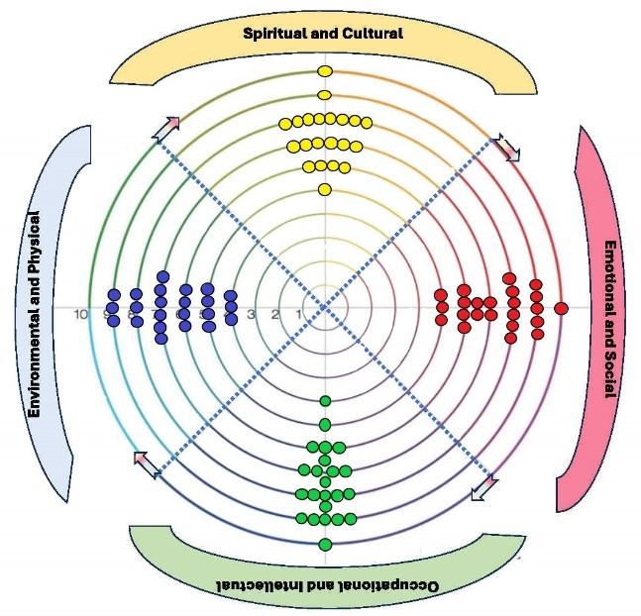
Overall Results
Measures of well-being in the 4 dimensions examined in this process were similar, with the Environmental/Physical score somewhat lower than the other three measures. The other three measures (i.e. Occupational/Intellectual, Spiritual/Cultural, Emotional/Social) were all very similar at least in their average scores. Each of the measures had a range of scores that included 10 for 3 of the 4 categories. Only Environmental/Physical did not score a 10.
Scores in the range of 7.4-7.6 indicate a high degree of satisfaction in these measures, but there are details in each score that are important to highlight. But it is clear that the Environmental/physical dimension is in need of some work.
The BSD Team’s wellness scores were colored each wellness dimension “pizza slice” creating a visual “scattergram” of the teams perceived overall wellness.

Table 1. Scores for measures of central tendency for 4 dimensions of well-being within BSD
 | Occupational/intellectual | Spiritual/Cultural | Environmental/Physical | Emotional/Social
mean | 7.49 | 7.6 | 6.4 | 7.4
median | 8 | 7 | 7 | 8
mode | 8 | 8 | 7 | 8
min | 4 | 5 | 4 | 5
max | 10 | 10 | 9 | 10

Frequency Analysis
The frequency of scores provided by BSD employees provided interesting insights into reports of well-being. Two dimentions (eg. Occupational/Intellectual and Spirtual/Cultural) seemed to have a somewhat normal distribution with peak frequency at 8 and declining frequencies on either side of that score. The Environmental/Physical dimention also had a peak frequency (albeit at 7) but the frequencies on either side of that peak were flat indicating a wide range of assessments on the Environmental/Physical dimention. Finally, the Emotional/Social dimention had an atypical distribution with high frequencies at 6, 8 and 9, but with low frequencies at 5, 7 and 10. This indicates that there are wide diversity of opinions as to the Emotional/Social well being, despite measures of central tendancy showing relatively high scores.

Table 2. Frequency distribution of scores for 4 dimensions of well-being in BSD
 | Occupational/intellectual | Spiritual/Cultural | Environmental/Physical | Emotional/Social
1 | 0 | 0 | 0 | 0
2 | 0 | 0 | 0 | 0
3 | 0 | 0 | 0 | 0
4 | 1 | 0 | 3 | 0
5 | 1 | 1 | 4 | 3
6 | 4 | 4 | 4 | 6
7 | 5 | 6 | 6 | 2
8 | 6 | 8 | 3 | 6
9 | 5 | 2 | 3 | 5
10 | 1 | 1 | 0 | 1
sum | 23 | 22 | 23 | 23
Values associated with well-being dimensions.
Each participant was encouraged to write out up to 3 values associated with each of the 4 dimensions of well-being that BSD should strive for in the future. The complete list of submitted values can be found at the end of the document. I attempted to classify each of the values into a category and then tally a frequency of the number of times that category was mentioned.

Occupational/Intellectual

The most frequently noted values in the occupational/intellectual dimension were provision of training opportunities and collaboration among BSD employees. Several other values were mentioned, with work-life balance and better communication coming in second.

Spiritual/Cultural
There were few values associated with Spiritual/Cultural dimension, but there was a strong desire to improve our language abilities through language classes. There was some need to start a beginners class. The other categories generally involved greater participation in feasts and other ceremonies. A few mentioned that BSD has a good balance in this dimension.

Environmental/Physical

This dimension received the lowest score of all four dimensions and the values associated with this dimension show were the concerns lie, in GLFIWC physical building. By far the most comments or listed values concerned either with a new building or fixing the building we have. Next most popular value had to do with physical activity and providing some opportunity for this.

Emotional/Social

As we saw with this dimension on the well-being scores, there is a wide range of diversity in the values associated with this dimension. The common element here is that BSD employees want to have opportunities to talk with each other, share a meal together and be active together. We have developed into a Division that cares for one another and we want to find ways to support each other.

Value statements submitted. These were categorized and summarized above.

Emotional / Social
- Better communication – monthly bio division meetings
- Taco Tuesday followed by nap time
- More out of optional events (softball team?)
- Long term friendships/support – we support each other within bio
- Continue ReCharge events -possibly with summer interns (overnight camping)
- People feel valued and included
- Continue to support well-being of all staff
- Kudos to all staff for making GLIFWC supportive in these aspects
- Groomed ski trail outside building
- Continued support for exercise time
- Continued support for working at home
- More collaboration between divisions
- Great! But maybe sharing info, invites to more events so EVERYONE is aware and has an opportunity to participate
- I value interdisciplinary teams. Brings different perspectives and challenges me intellectually

Occupational/Intellectual
- Better communication in and between different sections
- Fix heat issues (hard to focus when building is too hot)
- Continuing the current encouragement to learn new skills/train
- Better office space (more room for everyone)
- More time for training and professional development
- More training and support
- Additional opportunities for bio staff interaction/collaboration (division mtgs.)
- Developmental opportunities like courses or technical skill training, support for conference attendance
- Cross training/assist each other with work – to learn each other’s jobs to really understand Treaty Rights
- More collaboration and support across divisions
- Access to journal articles
- Interdisciplinary teams bring different perspectives and good intellectual challenges
- More brown bag sessions
- More training opportunities, more staff (too much on out plates) better work-life balance
- Scholarship opportunities
- More interaction across BSD (monthly meetings, monthly lunches, etc.) where we can share and discuss projects, current issues, collaborative opportunities to help bio function as a whole. Many topics span the scope of multiple sections work and we could be more effective with more communication and collaboration or at least discussion awareness and ideas
- Better work-life balance
- Provide more opportunities for staff to advance knowledge, skills, and compensation
- More lunchtime seminars sharing research
- Would it be possible to maybe look into workshops on how to be better organized and focused (with one goal being increasing efficiency and productivity) without adding more stress (training should also help reduce stress) Being more efficient would help reduce work leaking into weekends.

Spiritual/Cultural
- Great
- I believe we hance a nice balance in this category
- I value an environment of inclusion and education. Sometimes during ceremonial events like feasts, I appreciate and open discussion of cultural practice rather than feeling afraid of mis-stepping or misspeaking
- More cultural events that are strongly encourage (makes it easier to justify taking the time)
- Continue “Feast” style events with elders to continue to learn about the past such as the Waabanong Run Feast
- Connection to mother earth; more Ojibwemowin, feasts, retreats, gathering medicines
- More opportunities to learn language aside from picking up a word here or there
- More use of Ojibwemowin
- Starting a BEGINNER language class
- Additional Ojibwemowin classes (beginner level)

Environmental /Physical
- New office building to create an individual identity – public perspective is that GLIFWC is a Bad River entity
- Improve heat/cool/humidity control; option to work out @ work
- More parking, more carpooling, charging stations for electric vehicles, more hybrid vehicles for work use
- Workspace comfort improvement – Climate control and air quality
- Update building HVAC/windows
- Office windows
- Moderate temp in office
- Women’s restroom runs out of toilet paper – WHY? There is a spot for 2 full rolls
- We could use a clean physical space – office space cleaning could use great improvement
- Groomed ski trail behind building, New nets for basketball hoops @ center
- Encouragement/incentives for carpooling or reducing driving at work
- Office is too crowded. I like working in the same building/nearby coworkers as it provides an environment where interaction/strengthening relationships is easy, BUT not having privacy or a door to close makes it difficult to impossible to “close the door” and focus when needed without random interruptions/distractions
- Better workspace. More space and healthier building
- Heat/AC; Parking; office space
- Fix HVAC system; more comfortable/private work and office spaces
- Need large enough office space to accommodate all staff
- Physical space is often limited. Air management/climate control is out of control
- More space for staff; heat/AC issues fixed
- More work vehicles that get good gas mileage (IE not trucks)
- We are probably somewhat short of inclusive space for staff. Would be nice to have more of those spaces with windows but space is limited
- Outdoor area with picnic tables would be nice for summer work
- Physical activities – team activities, games, sports, outdoor fun together
- Team walks or friendly competition

Appendix II – Recharge Recipes
The following recipes were tested and gathered at the Winter Recharge Dec. 4-6, 2023
Breakfast Sausage Recipe by Miles Falck
- 5 lbs. Venison
- 5 lbs. Pork Trim
- 1.5 C Chopped Onion
- 1 C Maple Syrup
- 2 T Sage
- 1 T Black Pepper – med grind
- 5 t Salt - Kosher/Canning
- 2 t Cayenne
- 2 t Thyme
- 1 t Savory

Italian Sausage Recipe by Miles Falck
- 5 lbs. Venison
- 5 lbs. Pork Trim
- 4 T Salt - Kosher/Canning
- 4 T Fennel
- 2 T Black Pepper – med grind
- 2 T Crushed Red Pepper

Jerky Recipe by Jose Estrada
- 10 tablespoons La Choy soy sauce
- 7 tablespoons Heinz Worchester sauce
- 5 tablespoons Hickory Flavored liquid smoke
- 3 tablespoons Heinz ketchup
- 1 teaspoon salt
- ½ teaspoon black pepper
- ½ teaspoon McCormick garlic powder
- ½ teaspoon McCormick onion salt

Grind all meat through 3/8” plate. Add other ingredients plus ~1-2 cups of cold water (meat should squirt between fingers easily when making a fist). Grind again with 3/8” plate. Stuff in bulk bags or sheep casings.

Grind all meat through 3/8” plate. Add other ingredients plus ~1-2 cups of cold water (meat should squirt between fingers easily when making a fist). Grind again with 3/8” plate. Stuff in bulk bags or hog casings.

Cut meat into thin strips; combine ingredients and marinade venison overnight; dehydrate for 5 hours at 160 degrees.

White Corn Soup Recipe by Jen Falck
- 1 lb corn
- 1 lb dry beans
- 1 pork hock or turkey leg (smoked)
- 6-8 cups Soup stock or water

Prepare corn:
Boil corn in hardwood ash for about an hour or soak overnight. Rinse off the ash and hulls by rubbing corn against the side of a colander under running water. Boil again for one hour in fresh water until kernels are plump. May need to add water as corn rehydrates.

Cook:
Cook beans and stock overnight in Nesco.
Add corn and meat in the morning to be ready for lunch.

Summer Sausage Recipe by Miles Falck
- 10 lbs. Venison
- 10 lbs. Pork Trim
- 20 Garlic Cloves
- 8 T Powdered Sugar
- 5 T Mustard Seed
- 11 T + 1 t Salt - Kosher/Canning
- 3 T + 1 t Black Pepper – coarse grind
- 4 t Cure #1 (prevents botulism growth in smoker)
- 1 t Ascorbic Acid (Vit C - retains color in smoker)

Grind all meat through 3/8” plate. Add other ingredients plus ~2-3 cups of cold water (meat should squirt between fingers easily when making a fist). Grind again with 3/8” plate. Stuff in collagen casings (3 lbs. each) and tie off tightly with butcher twine. Refrigerate overnight or longer if desired for flavors to meld. Hang sausages in smoker so they do not touch each other, insert a temperature probe into one of the outermost sausages to monitor internal temperature. Smoke 4-6 hours (more if desired) keeping smoker at ~ 120 degrees. After smoking, raise the internal temperature of smoker to 160 degrees. When sausages reach internal temperature of 155 degrees, place them in a cold-water bath until internal temperature drops to 100 degrees. Hang at room temperature for 1 hour or longer to bloom. Refrigerate.

Potato Sausage Recipe by Travis Swanson

Ingredients:
- 5 lbs Potatoes
- ¼ cup Salt
- 5 lbs Venison
- ¼ cup Pepper
- 4 lbs Pork Butt
- 1 tbsp Allspice
- 2 lbs Onions
- 1 tsp Ginger
- Hog Casing
- 2 tbsp Garlic (Optional)
Prep:
Dice potatoes small enough to fit through your grinder, rinse potatoes after dicing. Mince onions or quarter small enough to grind, minced will leave larger chunks of onion in the finished product. Grind venison, pork, potatoes with course grinding plate. Alternating ingredients during grinding process will help mix and blend ingredients together. Once the product is ground, add spices and blend until evenly seasoned.
Stuff ingredients loosely into hog casing, if casing is stuffed too full it could lead to ruptures while cooking. Once the casing is filled, twist sausages into desired lengths. A length of 14-20 inches is
optimal, 14-inch-long sausages is a light meal for 1-2 people and 20 inches is a moderate serving for 2-3 people.

Cook:
Potato sausage contains pork and should be cooked thoroughly. Boiling a potato sausage for 12-14 minutes on a low to moderate boil is sufficient to cook the sausage. An indicator is retractor of the
casing near the ends and an overall tightening due to the ingredients swelling inside the casing. To finish the sausage, sear the sausage on medium heat with 1 tbsp of butter or oil to brown the casing. While browning the casing, you should see the juices inside of the sausage beginning to boil.

Serve:
Let cool for a few minutes to prevent injuries. Enjoy hot and slice with knife to desired sizes.

